ABSORBED BY LIGHT by Gali Lucas and Karoline Hinz (2018)

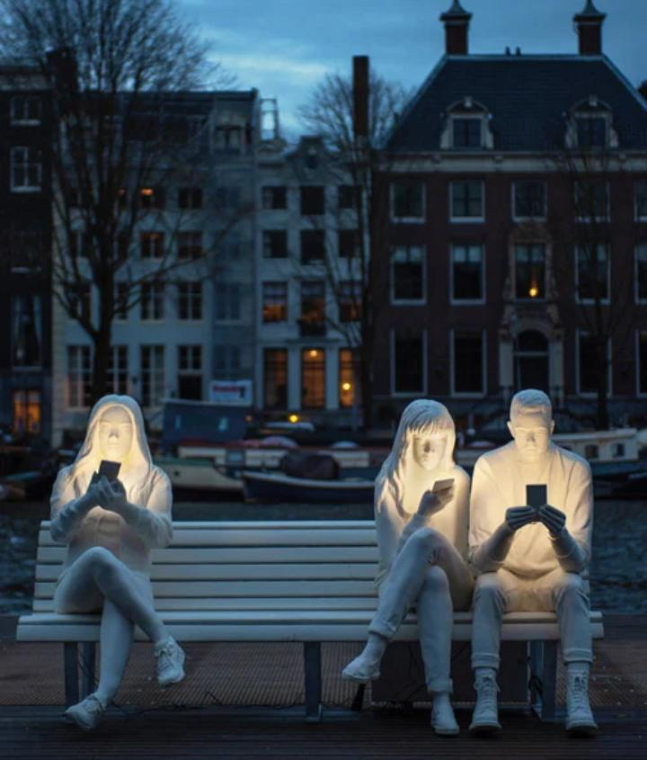
The Tittle; Absorbed by Light
Artist name; Gali Lucas And Karoline Hinz
Date; 2018
Location; Outside the Hermitage In Amsterdam

